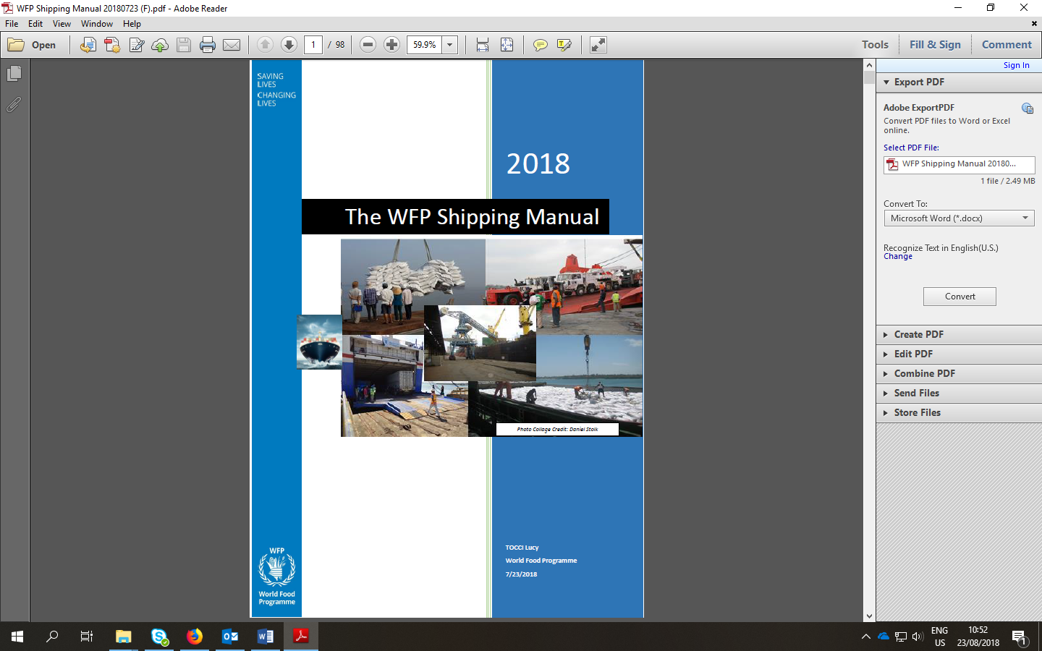

Questionnaire on disability-inclusiveness of potential vendors of food commodities
March 2021, rev. 2

Fe
SAVING
LIVES
CHANGING
LIVES
September 2018

Questionnaire on disability-inclusiveness of vendors

WFP is committed to implement the United Nations Disability Inclusion Strategy (UNDIS). As part of the implementation of the UNDIS, WFP promotes purchasing from disability-inclusive vendors and encourages its vendors to be inclusive of persons with disabilities.
A disability-inclusive vendor is a vendor which makes a dedicated, consistent, and measurable effort to implement disability-inclusive practices. Vendors can show that they are disability-inclusive through a variety of means such as, for instance, having an organizational policy on disability inclusion, recruiting and hiring people with disabilities, offering reasonable accommodation to candidates and personnel with disabilities, providing accessible premises, ensuring that their supply chains are disability-inclusive, or manufacturing accessible products following Universal Design principles.
WFP is interested in the efforts made by the its vendors towards including persons with disabilities and would like to collect information about such initiatives. Vendors who wish to do business with WFP must complete this questionnaire on disability-inclusiveness. It is important to note that the specific answers provided will not preclude a vendor from participating in WFP’s business.
- Do you have a general disability-inclusion policy? If yes, please provide details.
- Do you have a policy that promotes the employment of persons with disabilities (this does not need to be specific and could be part of the general human resources policy)? If yes, please provide details.
- Do you employ persons with disabilities? If yes, please provide details.
- Do you have a policy that foresees the provision of reasonable adjustments to persons with disabilities (e.g. applicants, employees, suppliers, visitors) who so require? If yes, please provide details such as, for instance, a registry of requests for adjustments made and their status.
- Do you require your suppliers to be disability-inclusive? If yes, please provide details such as a respective policy or written agreements you may have.
- Do you engage or consult persons with disabilities in the development of your products or services? If yes, how?

